Future Interns

Cyber Security Internship – Task 3

Secure File Sharing System
Submitted by: Mersilin Princy M
Duration: October 2025 – November 2025
Organization: Future Interns

1. Introduction
This project, completed as part of the Cyber Security Internship at Future Interns, focuses on developing a Secure File Sharing System. The system ensures that files are uploaded, stored, and downloaded securely by implementing AES encryption, protecting them from unauthorized access.

2. Objectives
- To develop a secure file upload and download web application.
- To implement AES encryption for safeguarding data at rest and during transfer.
- To design a basic key management process for encryption security.
- To ensure data integrity and confidentiality throughout the process.

3. Tools & Technologies Used
- Python Flask – for backend web development.
- HTML, CSS, and JavaScript – for the front-end interface.
- PyCryptodome – Python library for implementing AES encryption.
- Postman – for API testing and endpoint verification.
- Git & GitHub – for version control and code hosting.

4. System Implementation
The system was developed using Flask to handle file uploads and downloads. When a user uploads a file, it is immediately encrypted using AES (Advanced Encryption Standard) before being saved on the server. Upon download, the file is decrypted using the same key, ensuring secure transmission and storage.
The application ensures that files remain unreadable even if intercepted, and that only authorized users with the correct decryption key can access the content.

5. Security Features Implemented
- AES encryption applied to all uploaded files.
- Unique encryption key management for each file session.
- Secure download process with file decryption on demand.
- Validation for file type and size to prevent malicious uploads.

6. Screenshots / Demonstration
Screenshots of the system interface, file upload process, and encryption logs can be added here to visually demonstrate the system’s workflow.
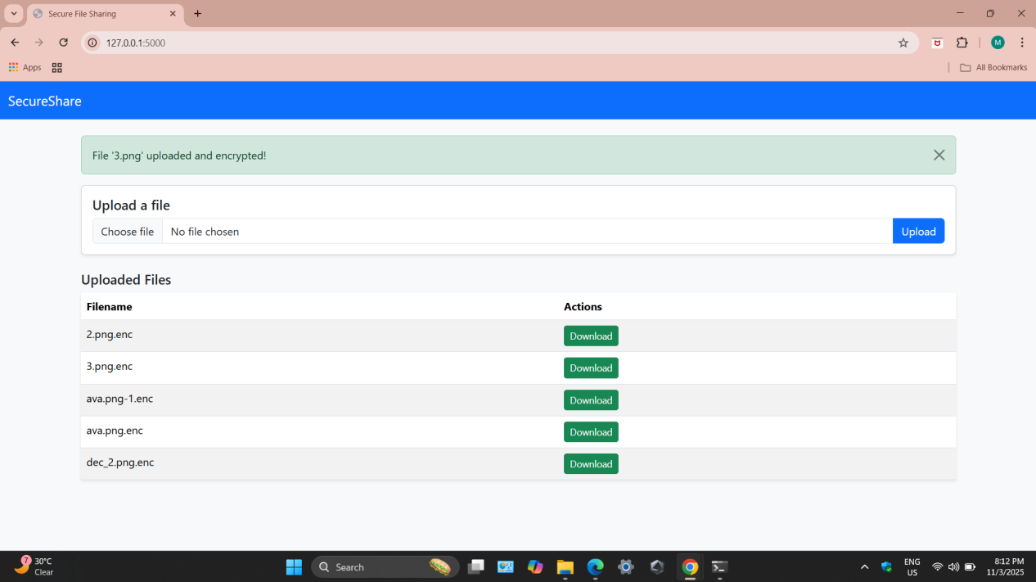
File upload page

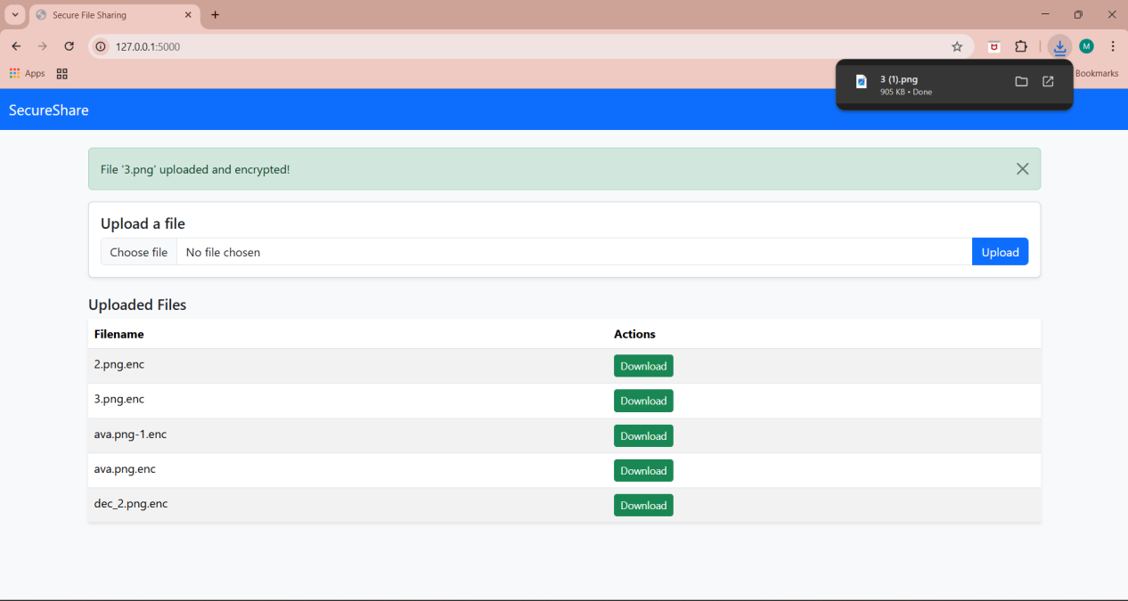
Successful decryption and download

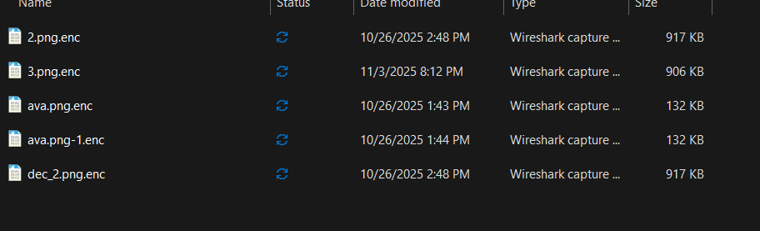
Encrypted file storage view

7. Results & Testing
The system successfully encrypts and decrypts files without data corruption. Tests were conducted to verify file integrity before and after encryption. The AES implementation proved efficient and reliable, providing strong protection against unauthorized access.
Tests with multiple file types (images, PDFs, text files) confirmed that encryption and decryption were consistent, maintaining file quality and structure.

8. Conclusion
This project provided hands-on experience in developing a secure web-based application, implementing cryptographic principles, and managing encrypted data.
The Secure File Sharing System demonstrates practical cybersecurity practices, enhancing both data confidentiality and integrity in digital file sharing scenarios.

